

Profitability Tool *©*

*Software Documentation*



Copyright to [FTI Touristik GmbH](http://www.fti.de/).

**Profitability Tool** is a VB.NET Desktop Application that imports daily bookings information and store them. Profitability Tool mainly aims to:

* Settle the margin profitability for **Meeting Point** *(difference between purchase & sales price)*.
* Settle the calculations deficit between **Meeting Point** and the **Tour Operators**.

**Installation**

1. The [SQL database](https://github.com/walidzakaria/ProfitabilityTool/blob/master/Database%20Script.sql) needs to be hosted into SQL Server. A full database schema is included [here](https://github.com/walidzakaria/ProfitabilityTool/blob/master/Database%20Script.sql).
2. Copy the files in Debug Folder into the client machines.
3. Create a shortcut to the executive file **Profitability_Tool.exe** into the user desktops.
4. Run the executive file **Profitability_Tool.exe** or the shortcut referring to it.

**Application Running**

Once you open the **Profitability Tool** the following happens:

* A login screen shows up.

[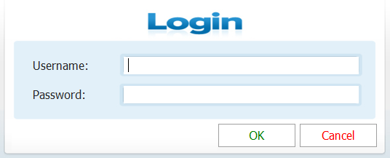](https://github.com/walidzakaria/ProfitabilityTool/blob/master/Screenshots/Login.png)

* When logged-in, the application main screen shows:

[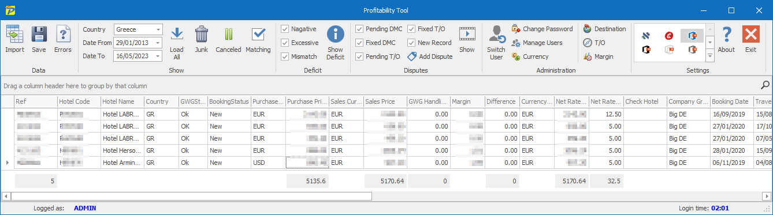](https://github.com/walidzakaria/ProfitabilityTool/blob/master/Screenshots/Main.png)

**User Permissions**

There are four different user profiles with different authority levels:

1. **Admin:** A user profile with the highest permission levels, and aimed to manage user accounts, and modify bookings.
2. **RS (Red Sea):** A user profile with permissions to **import & edit** booking entries.
3. **DMC:** A user profile with no permissions to **edit** bookings data, and with permissions to **create comments** and to change the bookings status to:
   * Fixed DMC
   * Pending DMC
   * Pending T/O
4. **TO (Tour Operator):** A user profile with no permissions to **edit** bookings data, and with permissions to **create comments** and to change the bookings status to:
   * Fixed T/O
   * Pending DMC
   * Pending T/O

**Note:** You can change user permission level any time.

**Pre-Configurations**

[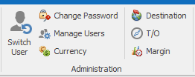](https://github.com/walidzakaria/ProfitabilityTool/blob/master/Screenshots/Administration.png)

In order to have **Profitability Tool** running properly, you need to configure the below:

* **Destinations:** You can find it in the **Destination** button in **Administration** ribbon group. Every destination should be defined as 2 Letter code and full destination name *(e.g. Code: "EG", Destination: "Egypt")*.

[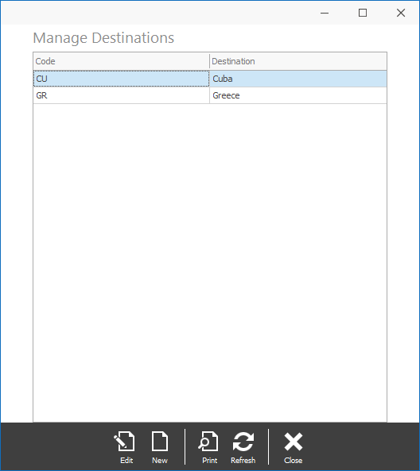](https://github.com/walidzakaria/ProfitabilityTool/blob/master/Screenshots/Destinations.png)

* **Tour Operators:** You can find it in the **T/O** button in **Administration** ribbon group.

[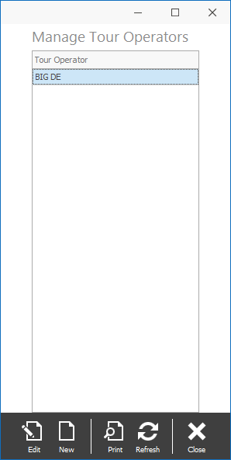](https://github.com/walidzakaria/ProfitabilityTool/blob/master/Screenshots/Tour_Operators.png)

* **Currency Exchange:** You can find it in the **Currency** button in **Administration** ribbon group. Every Currency can be defined with multiple rates based on travel dates.

[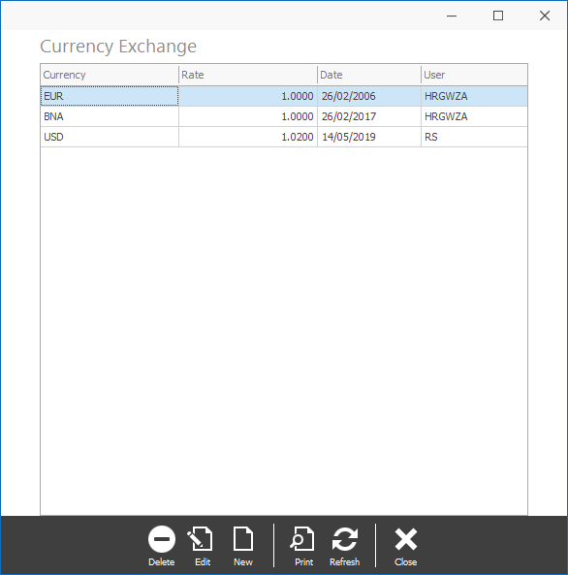](https://github.com/walidzakaria/ProfitabilityTool/blob/master/Screenshots/Currency.png)

* **Margins:** You can find it in the **Margin** button in **Administration** ribbon group. The margin includes the acceptable margin difference range between the purchase price and sales price, also the acceptable calculation discrepancy range between the **DMC** sales calculation and the **Tour Operator** cost calculation. The margin should be defined against each destination and tour operator.

[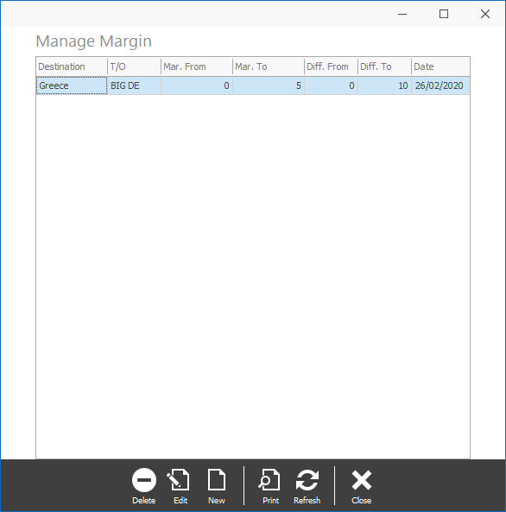](https://github.com/walidzakaria/ProfitabilityTool/blob/master/Screenshots/Manage_Margins.png)

* **Users Visibility** To be more secured every single user needs to be granted permission to see which destination and which tour operator. In order to set that, use **Manage Users** button in **Administration** ribbon group, select the respective user, and then press button **Options**.

[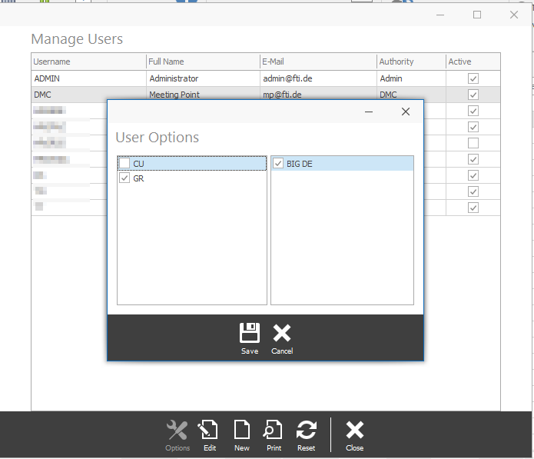](https://github.com/walidzakaria/ProfitabilityTool/blob/master/Screenshots/User_Options.png)

Select the user valid destinations & Tour Operators, and **Save**.

**Application Operations**

**Importing New Bookings**

[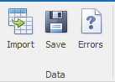](https://github.com/walidzakaria/ProfitabilityTool/blob/master/Screenshots/Data_ribbon_group.png)

1. Open the Excel report of the daily bookings, select all rows except for the header, and copy.
2. Go to **Profitability Tool** and press button **Import** in **Data** ribbon group.
3. Remove any undesired rows by selecting them, and pressing Del key.
4. Save the imported bookings, by clicking **Save** button in **Data** ribbon group. Make sure that there is no error message pops up, if so, please contact us.
5. Check if any bookings have missing parameters by clicking on **Errors** button in **Data** ribbon group. If any bookings appear, you can open every booking, and check the error log.

[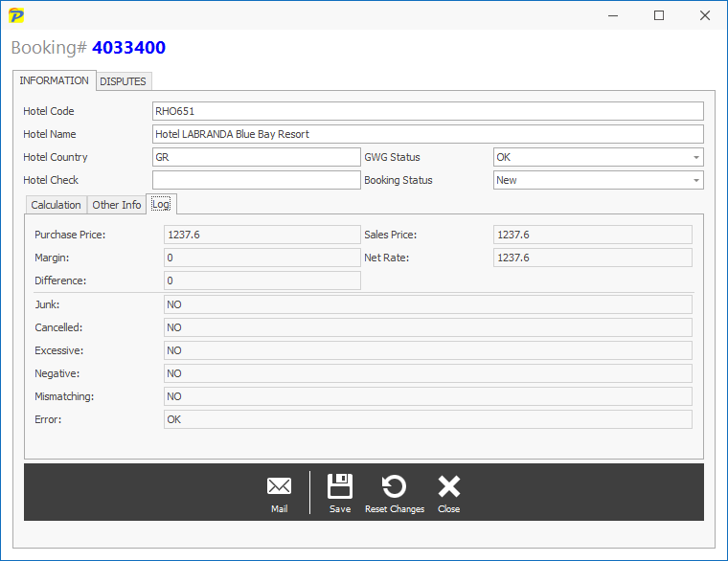](https://github.com/walidzakaria/ProfitabilityTool/blob/master/Screenshots/Booking_Information_Other_Log.png)

1. Fix the missing parameters, and resave the bookings again in order to recalculate those errors with the new parameters.
2. You can edit a saved booking by double-clicking it, change the data, and **save**.

**Showing Saved Data**

[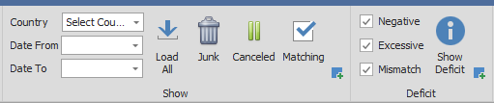](https://github.com/walidzakaria/ProfitabilityTool/blob/master/Screenshots/Show_and_deficit.png)

After saving the booking, they are automatically categorized as:

* **Junk:** Junk bookings are those that have one of the following criteria:
  + Status = "BNA", or "OnR".
  + MarginCheck = "Option".
  + NetRateHotelTC < 1
  + HotelName contains "rundreise", "circuit", or "roulette".
* **Canceled:** Cancelled bookings are those that have status as "CNX".
* **Matching:** Matching bookings are those that fulfill all matching parameters.
* **Deficit:** Deficit bookings are those that don't fulfil one or more of the matching parameters.

**Those are the matching parameters:**

* **No negative margin:** Sales price is higher than the purchase price.
* **No excessive margin:** The difference between the sales price and purchase price is within the range of the respective margin range.
* **No mismatch:** The difference between the DMC sales price and the tour operator cost price is within the range of the respective margin range.

**Filtering the Bookings:**

You can select the desired bookings category by selecting the following:

1. Select the target destination.
2. Select travel date from/to.
3. Click on the respective category button (Junk, Canceled, Matching, Deficit). Then the bookings show up in **Profitability Tool** grid. You can set further advanced filtrations using the grid powerful interactive filtration options. The grid has the below options:

* **Find:** You can search for any part in any column by pressing **CTRL + F**.
* **Filter:** You can add a filter to any column by hovering over the column header, the filter symbol will appear, click on it, and set the desired filter criteria.
* **Grouping:** You can group the rows against any desired column(s), and on multiple levels. This can be done by selecting the header of the desired column, then *drag & drop* it into the upper part of the grid *(group panel)*.
* **Sorting:** You can sort the rows by clicking on the desired column header. You can sort from *Ascending* to *Descending* or vice versa by repeating the mouse click.
* **Rearranging Columns:** Drag the column headers into the desired order.
* **Show/Hide Columns:** You can hide any column by dragging its header away from the grid. To show it again, right-click on any column header, and select **Column Chooser** a window will appear with all the hidden columns, double-click in the desired column you want to show.

**Changing Booking(s) Status**

After showing the desired category, and applying the needed filtrations, you can change the booking(s) status by:

* Double-Click on the selected booking if a single selection.
* Pressing **Enter** key if bulk selection.

[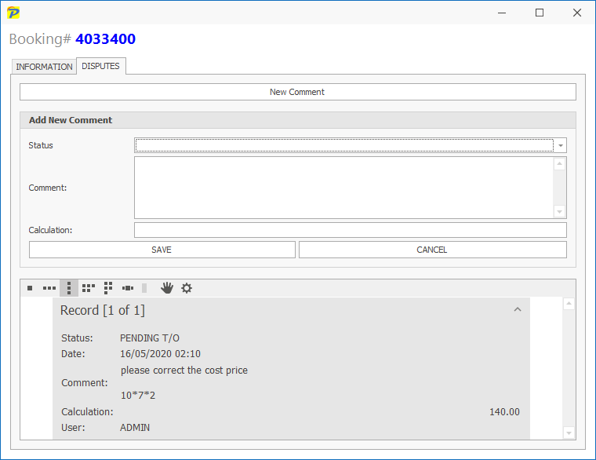](https://github.com/walidzakaria/ProfitabilityTool/blob/master/Screenshots/Booking_Disputes.png)

Then the comments/disputes window shows. In this window, you can see the older disputes and comments thread, and you can also create a new comment by following the below steps:

1. Click on button **New Comment**.
2. Change the desired status.
3. Insert your comment. *(the smart tool can also detect if you type any calculation and inputs its result into the calculation field)*
4. Optionally input a suggested rate, or leave it blank.
5. Press **Save**.

**Different Booking Status:**

* **Pending DMC:** The booking needs to be settled by **Meeting Point**.
* **Fixed DMC:** **Meeting Point** has settled the booking.
* **Pending Tour Operator:** The booking needs to be settled by the **Tour Operator**.
* **Fixed Tour Operator:** **The Tour Operator** has settled the booking.

**Working with Bookings in Dispute**

[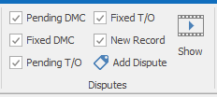](https://github.com/walidzakaria/ProfitabilityTool/blob/master/Screenshots/Show_booking_with_disputes.png)

Each DMC or Tour Operator can see its own disputed bookings only *(Fixed and Pending)*, and handle them by changing the status again.

**Note:** The main purpose is to eventually have all the deficit bookings as fixed either by DMC or by T/O.

**Requirements**

* Supported Operating Systems:
  + Windows 10.
  + Windows 7 Service Pack 1.
  + Windows 8, Windows 8.1.
  + Windows Server 2008 R2 SP1.
  + Windows Server 2008 Service Pack 2.
  + Windows Server 2012.
  + Windows Server 2012 R2.
  + Windows Vista Service Pack 2
* .NET Framework v4.5.2 or higher installed on the client machines.
* 1 GHz or faster processor.
* 512 MB of RAM or more.
* 4.5 GB of available hard disk space (x86) or more.
* 4.5 GB of available hard disk space (x64) or more.
* For maintenance a [DevExpress WinForms](https://www.devexpress.com/products/net/controls/winforms/) is needed & [VS.NET](https://visualstudio.microsoft.com/vs/).

**Software License**

Commercial Software. Copyright to [FTI Touristik GmbH](http://www.fti.de/).